Physics of color

Visible light is the light with a wavelength of about 380-780 nm. The spectrum of the light uniquely defines its color. The reflectance spectrum of an object, multiplied by the spectrum of the light projected on it, determines it’s color percepted by us.

Hue: the mean of the spectrum.

Lightness: the area under the whole spectrum (integration).

Saturation: the variance of the spectrum.

When mixed up, the RGB light’s absorbing and reflexing spectrum is simply the union of the seperated ones; the CMY (cyan-magenta-yellow) pigments’ absorbing spectrum is also the union but the reflexing one is the intersection.

Psychogical theory

Trichromatic theory

Raised by Young and Helmholtz. This theory suggests that human color perception relies on three kind of receptors, with different sensitivity to light of different wavelength.

Color opponent theory

Inspired by the fact of color aftereffect and color blindness, Herring suggests that every receptor should react to two colors (R-G, B-Y), one is excitatory and one is inhibitory.

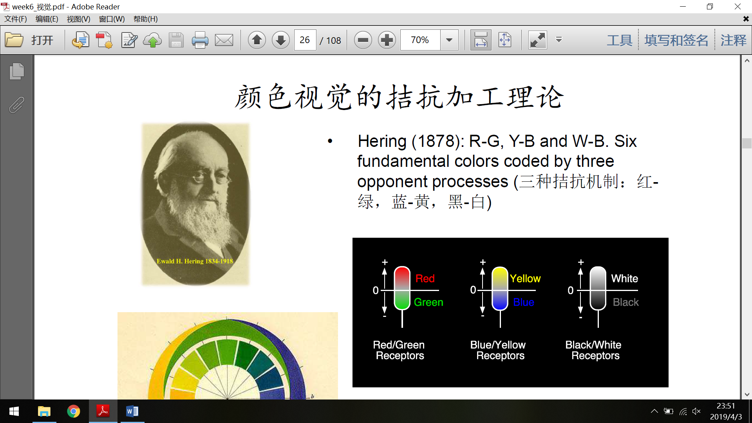

Dual process theory

This theory is based on the phsiological research about color vision, which suggests that the perception of color may contain two phases: at the retinal receptor level, it’s trichromatic; and at the ganglion cell level, it’s color opponent.

Color space

See the picture below. It’s suggested that the color we percept is based on cue, saturation and lightness.

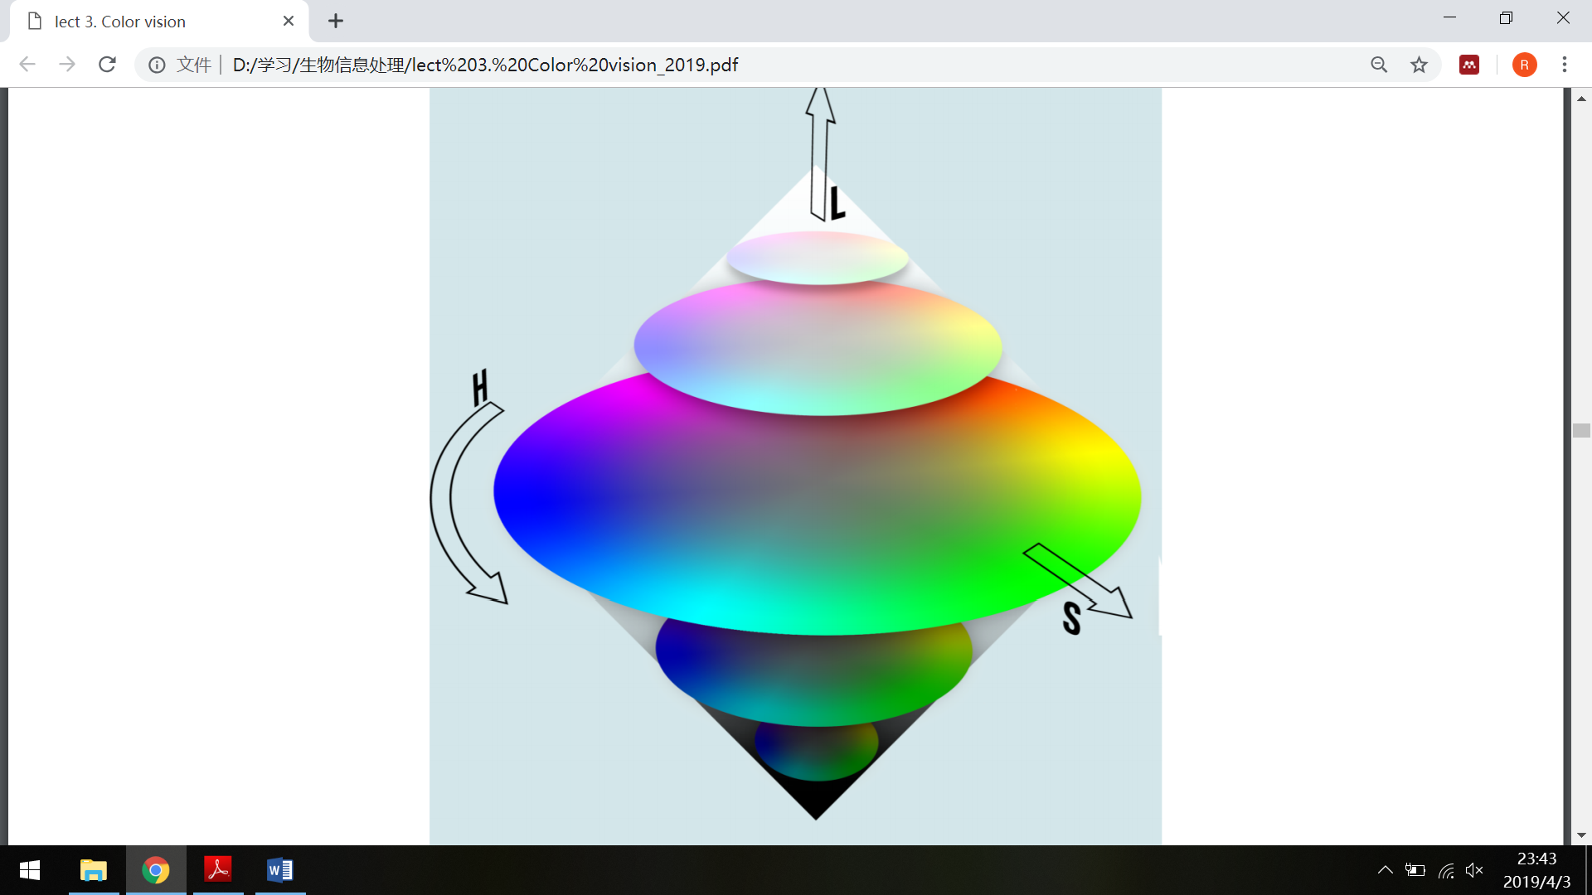

Physiological mechanism

At retinal level, the process is trichromatic, because we have three kinds of photoreceptors. But in RGC and LGN, some neurons have been found to behave like a color opponent cell, for example K cells. A possible model for the color opponent behavior of ganglion cells is shown below.

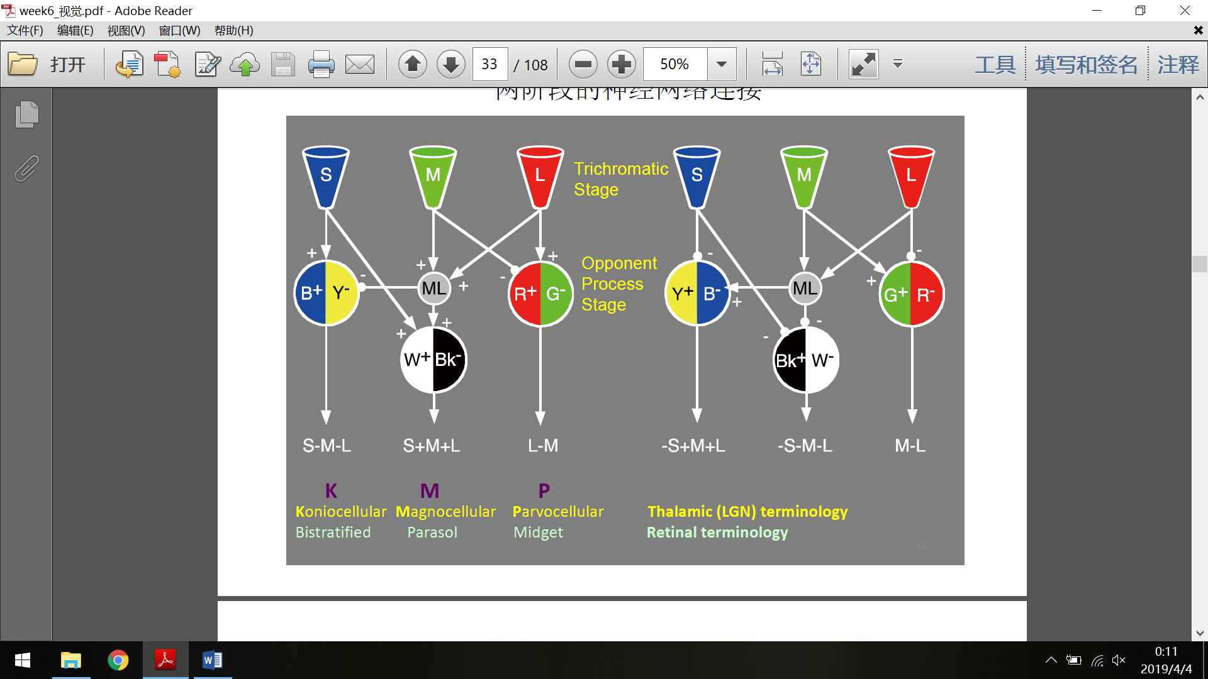

At cortical level, neurons in V1, V2 and V4 exhibits selective activation to colors. These neurons also have a concentric receptive field. Some of them are single-opponent cells, which are important for detecting color in an area; some are double-opponent, which are important for detecting the difference of color between different areas.

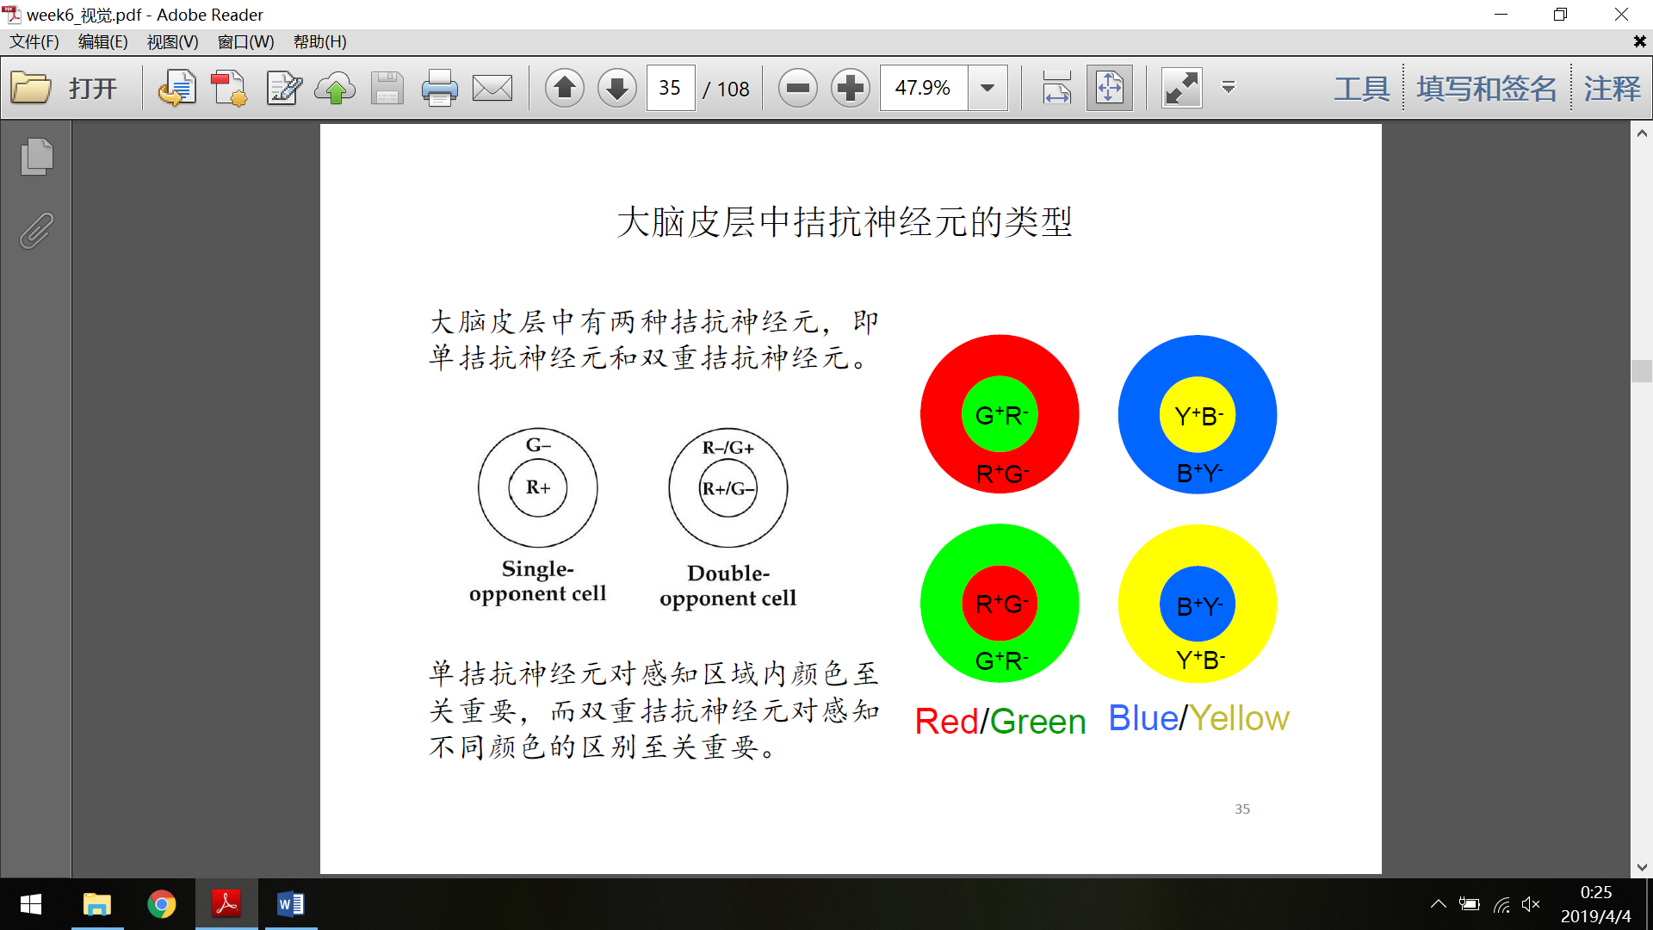

Color constancy

Lightness constancy

The amount of light reflexed into our eyes are different due to the different illumination, but the ratio between two areas stays the same.

Color constancy

The mechanism of color constancy may involve the prior knowledge in the memory, the supporting evidence in the environment, and the adaptation of ocular neurons’ sensitivity to different bands of light. V4 cortical neurons, which have a large receptive field, may have the ability to normalize the color, thus showing color-constant activity.